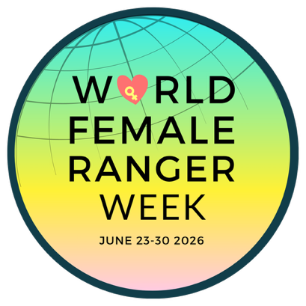

[Insert your organisation’s name here] is supporting World Female Ranger Week on June 23-30, 2026 to amplify the voices of female wildlife rangers on a global stage.

REAL WOMEN, Real Stories, Real Impact. This pioneering global awareness week, spearheaded by international NGO, How Many Elephants, celebrates and supports female wildlife rangers - They're bold, changing the game and paving the way for women to stand alongside men at the forefront of conservation, but they need allies. Still less than 11% of the global ranger workforce is female.

[Insert sentence on female rangers and why you are supportive of the work they are doing to protect wildlife and wild spaces.]

The founder of World Female Ranger Week, Holly Budge says, "having advocated for female rangers for over a decade, I've seen first-hand how these women are impacting lives; Protecting wildlife, uplifting communities and empowering other women. World Female Ranger Week is a time to celebrate their successes and recognise their unique challenges also."

WFRW Ambassador, Dr Gladys Kalema-Zikusoka from Uganda, says “I’m delighted to support World Female Ranger Week. Gender equity in the conservation arena is such an important and prevalent topic. There is still much work to do but World Female Ranger Week plays a key role in raising awareness of the work of female rangers and women in conversation in the broader picture.”​​​​​​​​

Join us in showing your support for brave female rangers who work tirelessly to protect the world’s most endangered wildlife. Find out more at www.worldfemalerangerweek.org and don’t forget to use hashtag, #worldfemalerangerweek.

- END -

Links:
www.worldfemalerangerweek.org
www.howmanyelephants.org
Instagram & Facebook: @worldfemalerangerweek @howmanyelephants
Hashtag: #worldfemalerangerweek

